A Recipe For:

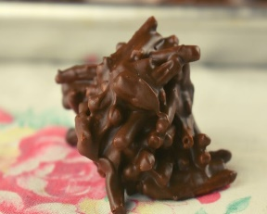 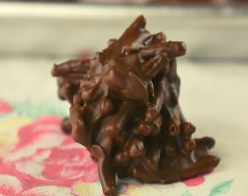

# 

# Ting-a-lings

**From the Kitchen of:** Grandma O’Leary

**Servings:** 4 dozen

**Prep Time:** 20 minutes **Bake Time:** **Bake Temp:**

**Ingredients:**

* 1 lb. sweet chocolate (if semi-sweet chocolate add ¼ cup sugar)
* 2 oz. bitter chocolate
* ½ tsp salt
* 6 cups grape nut flakes
* ½ cup walnuts

**Instructions:**

1. Melt chocolate and salt over hot water (double boiler).
2. Add grape nut flakes to the melted chocolate with the nuts.
3. Mix well.
4. Drop in heaps on waxed paper or in small muffin cups.
5. Cool.